Subtract-Answers
Key Stage 3: Paper1 Level 3_5
1.
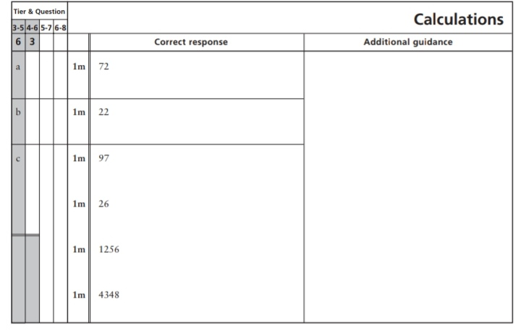
2.
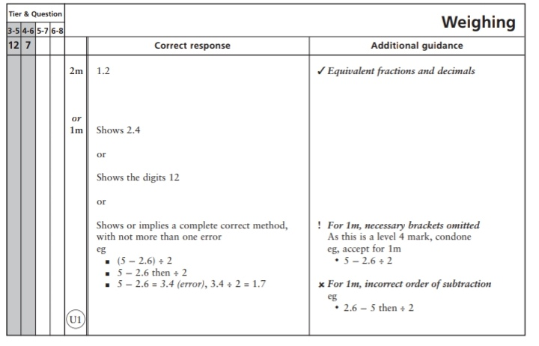
Key Stage 3: 2003 Paper 2 Level 3_5
3.
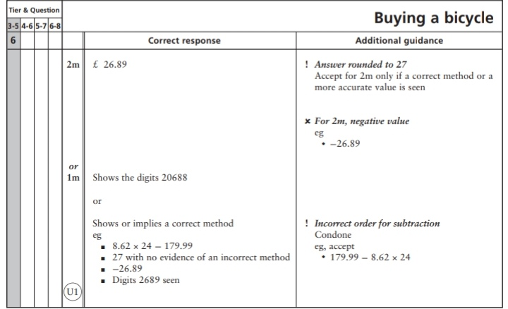
Key Stage 3: 2003 Paper 1 Level 4_6
4.
- 1256
- 4348

5.
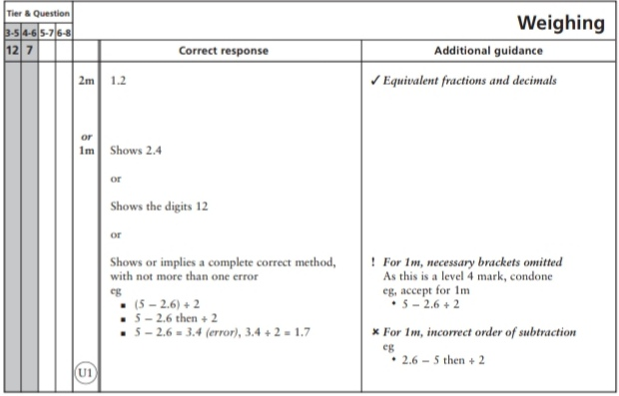
6.
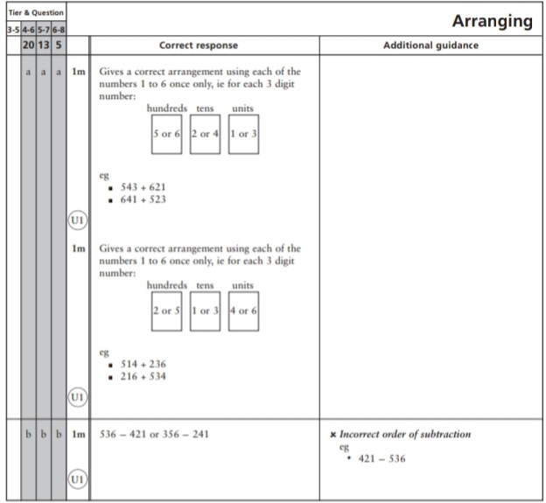
Key Stage 3: 2004 Paper 1 Level 3-5
7.
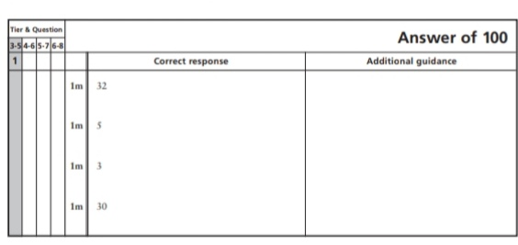
8.
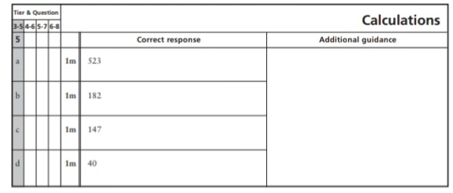
9.
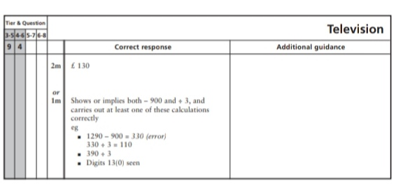
Key Stage 3: 2004 Paper 2 Level 3-5
10.
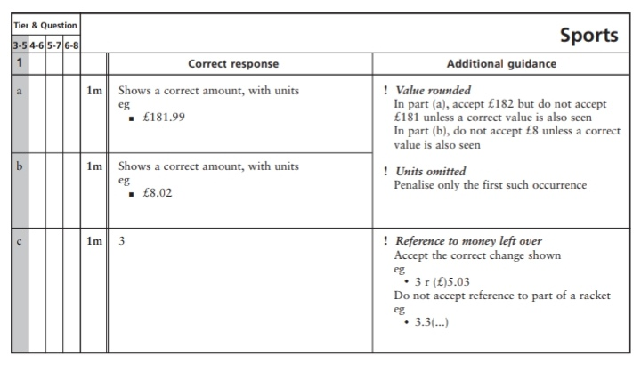
Key Stage 3: 2004 Paper 1 Level 4-6
11.
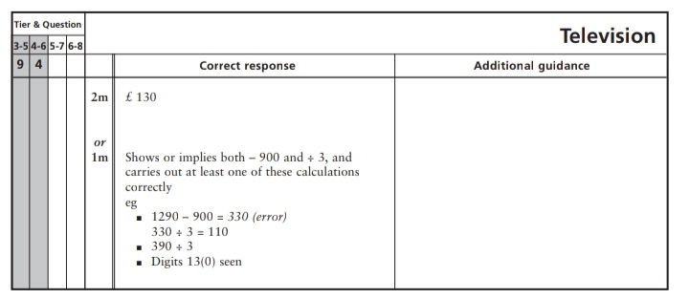
Key Stage 3: 2005 Paper 1 Level 3-5
12.
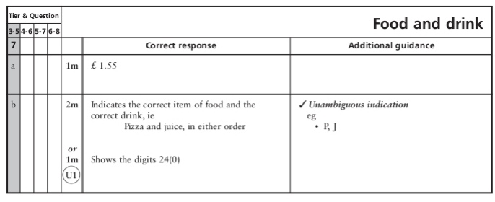
13.
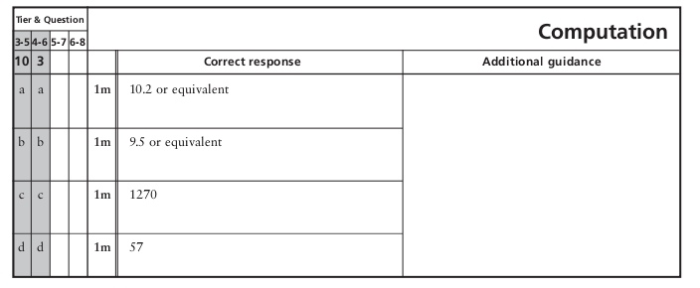
Key Stage 3: 2005 Paper 2 Level 3-5
14.
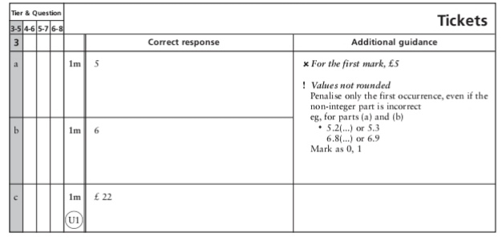
15.
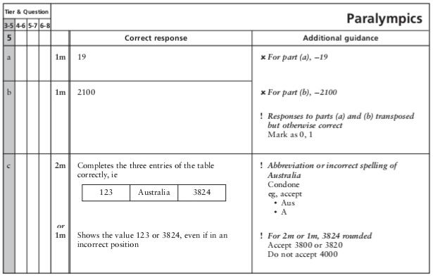
16.
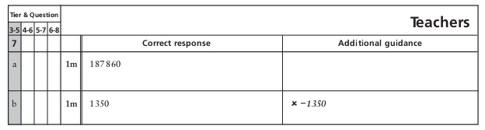
17.
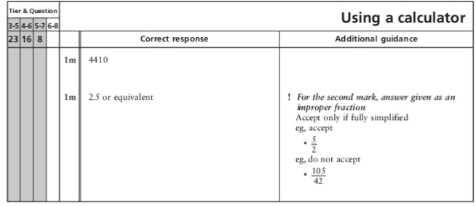
Key Stage 3: 2005 Paper 1 Level 4-6
18.
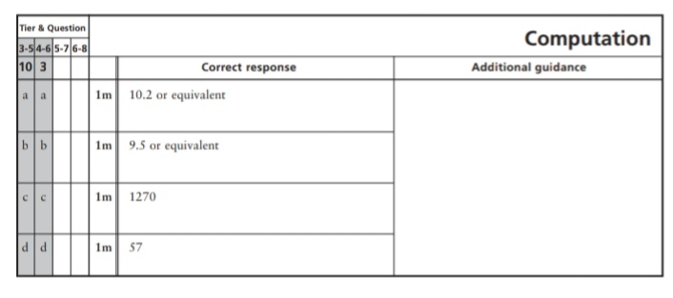
19.
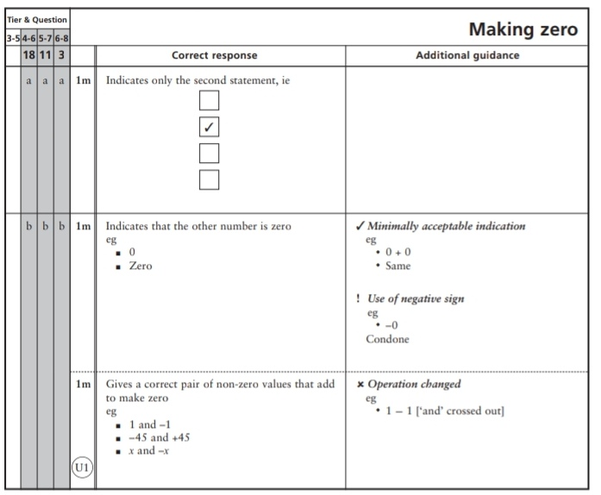
Key Stage 3: 2005 Paper 2 Level 4-6
20.
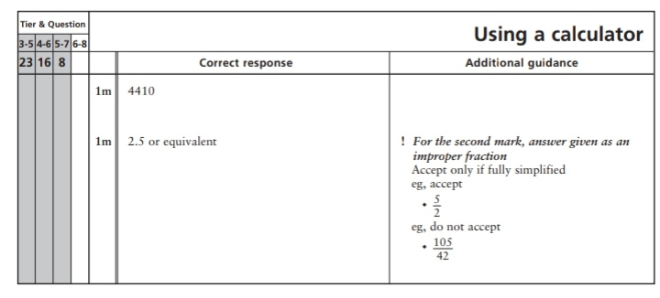
Key Stage 3: 2006 Paper 1 Level 3-5
21.
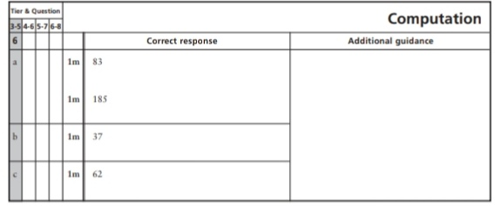
22.
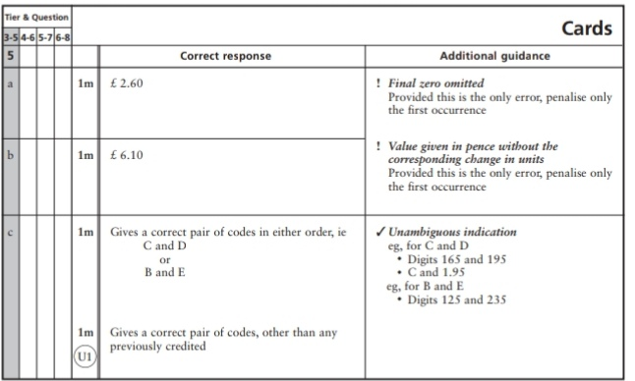
23.
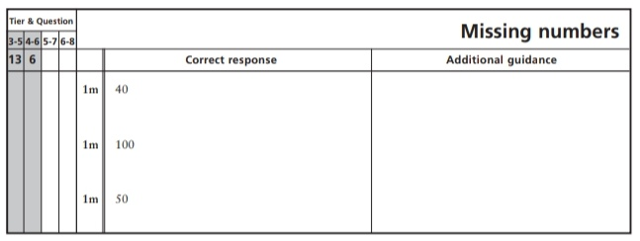
Key Stage 3: 2006 Paper 2 Level 4-6
24.
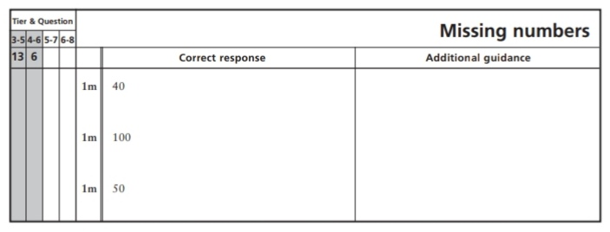
Key Stage 3: 2007 Paper 1 Level 3-5
25.
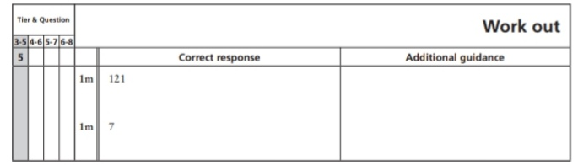
Key Stage 3: 2007 Paper 2 Level 3-5
26.
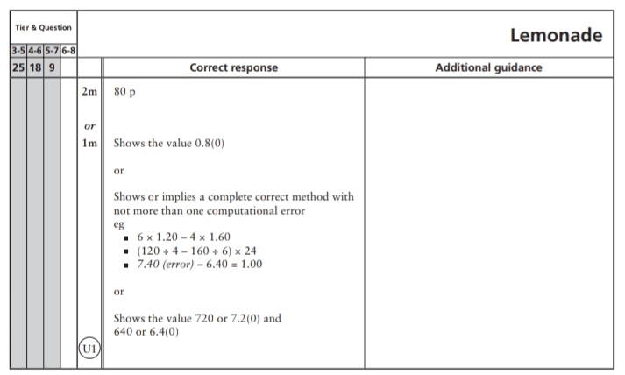
Key Stage 3: 2007 Paper 2 Level 4-6
27.
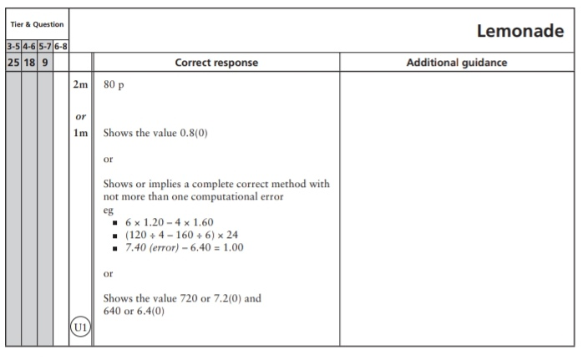
Key Stage 3: 2008 Paper 1 Level 3-5
28.
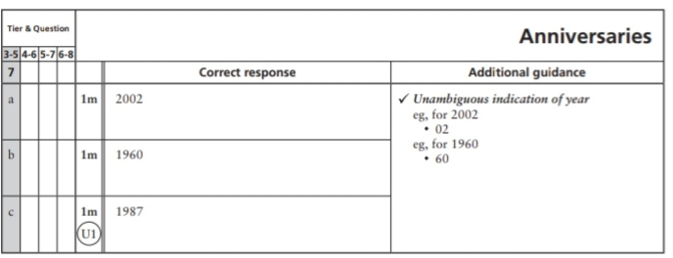
29.
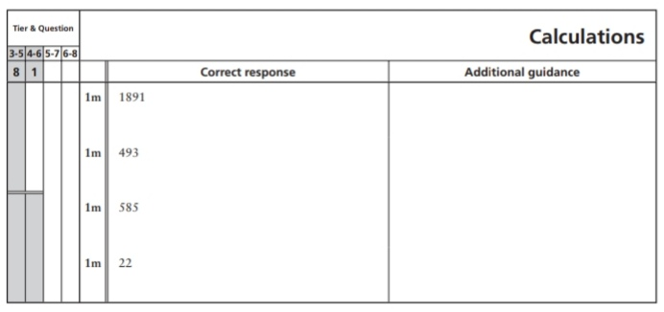
Key Stage 3: 2009 Paper 1 Level 3-5
30.
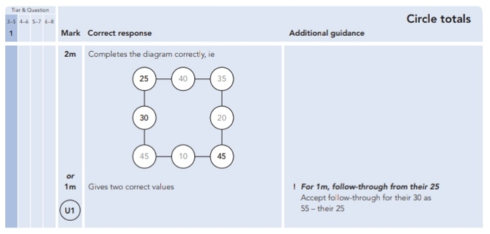
31.
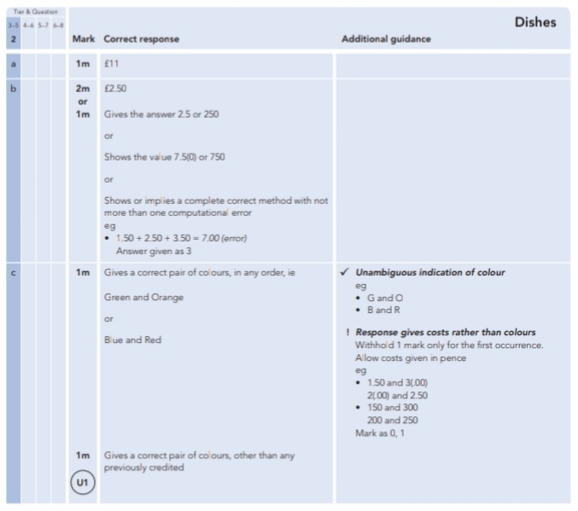
32.
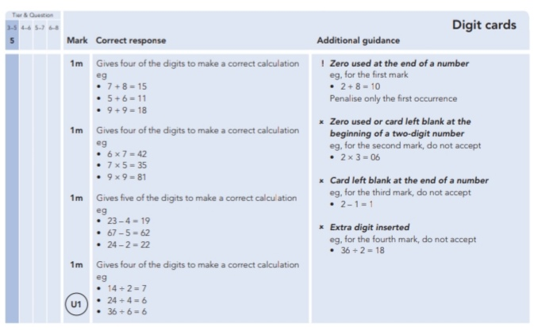
33.
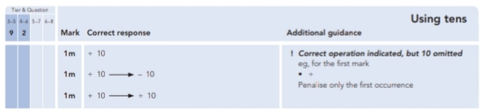
34.
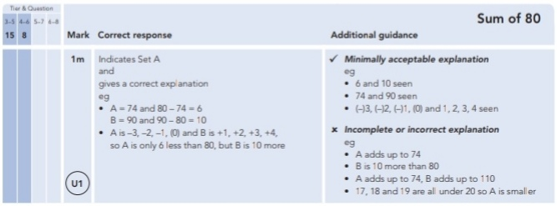
Key Stage 3: 2009 Paper 2 Level 3-5
35.
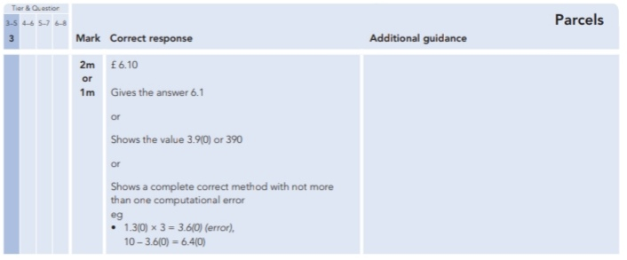
36.
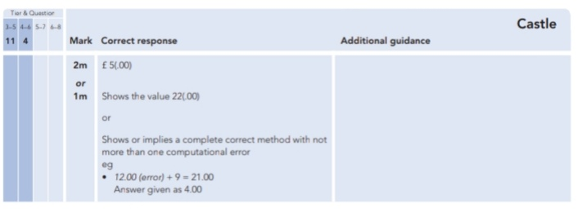
37.
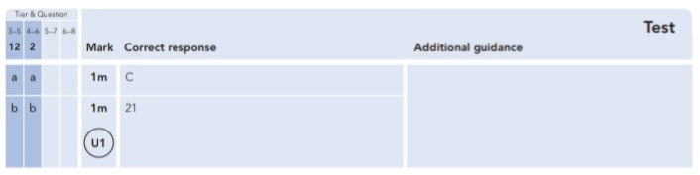
Key Stage 3: 2009 Paper 1 Level 4-6
38.
39.
40.
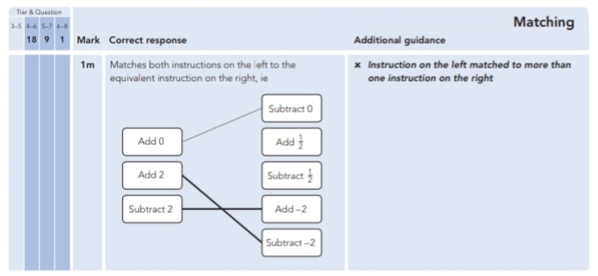
41.
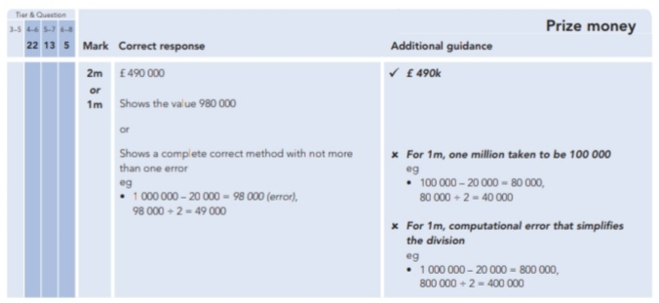
Key Stage 3: 2009 Paper 2 Level 4-6
42.
43.
Key Stage 3: 2010 Paper 1 Level 3-5
44.
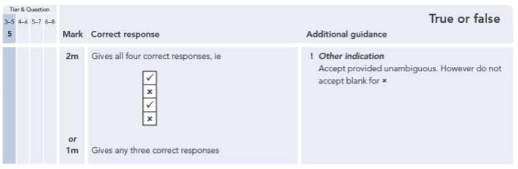
45.
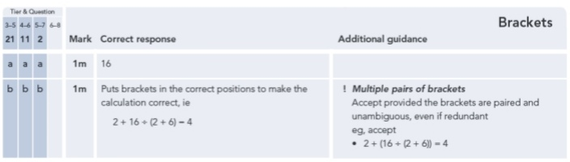
46.
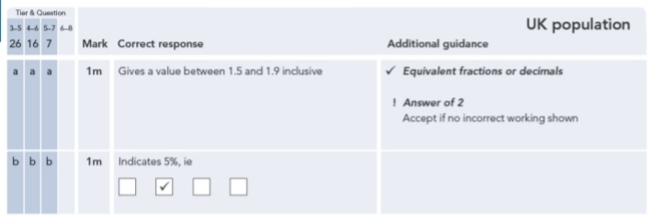
Key Stage 3: 2010 Paper 2 Level 3-5
47.
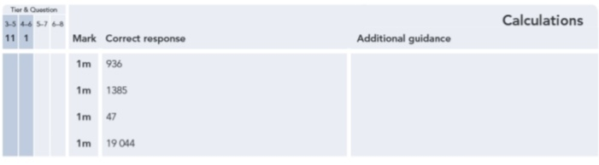
48.
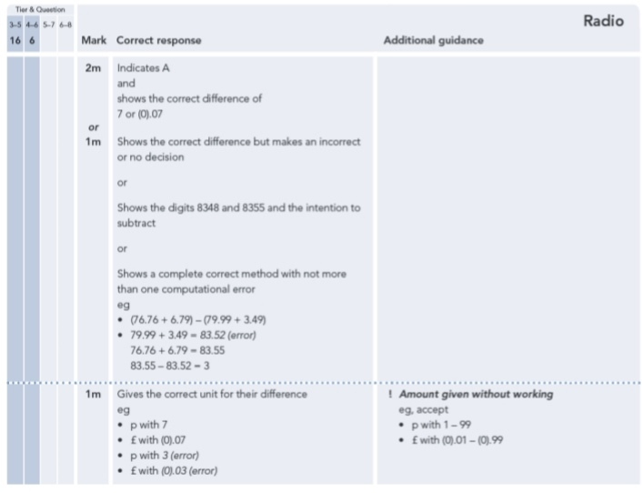
Key Stage 3: 2010 Paper 1 Level 4-6
49.
50.
Key Stage 3: 2010 Paper 2 Level 4-6
51.
52.
Key Stage 3: 2011 Paper 1 Level 4-6
53.
